**On-demand truck app: version 1.00 (Breno Souza)**

**Narrative description:**

The On-Demand Truck App is designed to facilitate the process of booking and managing truck services. Users can request truck services for various purposes, such as moving furniture, transporting goods, or any other needs. The app aims to provide a user-friendly interface and efficient service delivery.

**User Stories:**

* As a registered user, I want to be able to request a truck service for transporting my belongings to a new location or for another service.
* As a truck driver, I want to be notified of new service requests in my area so that I can accept and fulfill them.
* As an admin user, I want to manage user accounts, track service requests, and monitor overall app performance.

**CRUD Capabilities:**

**Create:** Users can create new service requests by providing necessary details such as pickup/delivery locations, date, and type of service.

**Read:** Users can view their past and current service requests, as well as browse available truck services and pricing information.

**Update:** Users can modify or cancel their service requests before they are assigned to a driver, subject to cancellation policies.

**Delete:** Admin users have the ability to delete or archive outdated or redundant service requests from the system.

**Database Schema:**

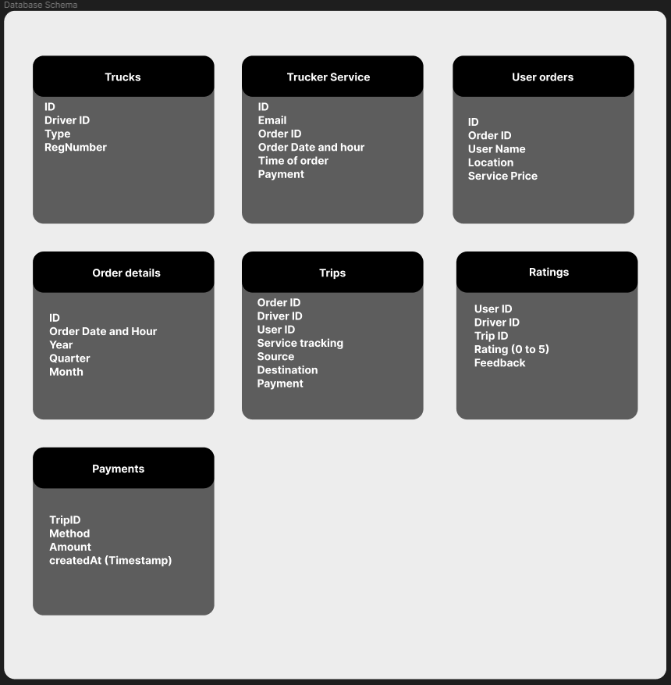

Data Flow

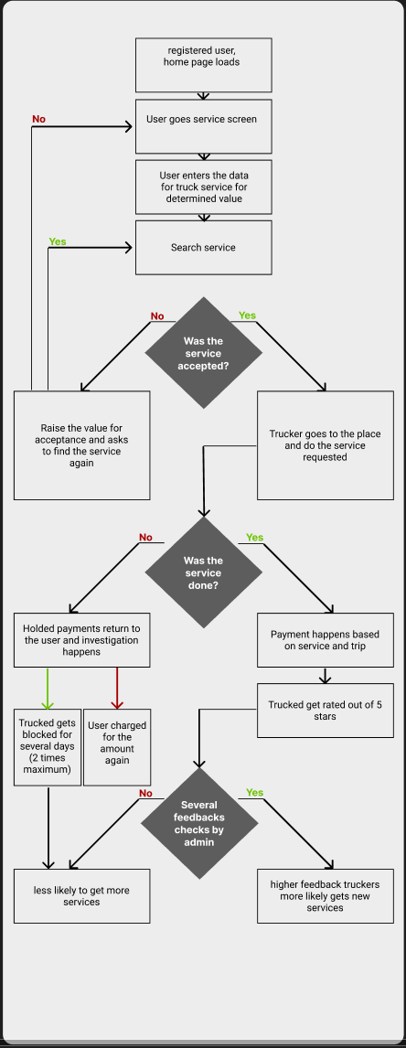**Dataflow:**

**Wireframe 1:**  
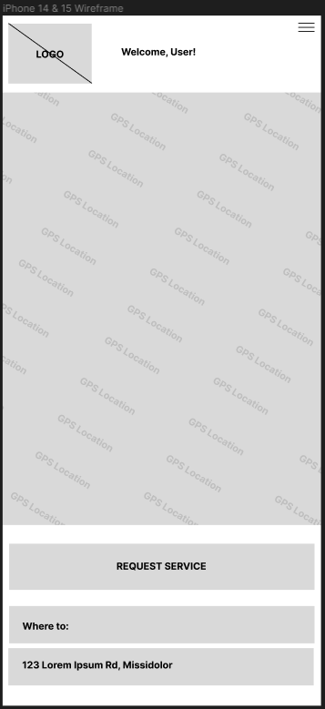

**Wireframe 2:  
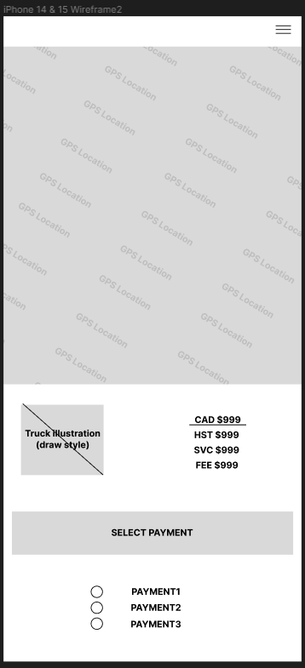**

**Wireframe 3:  
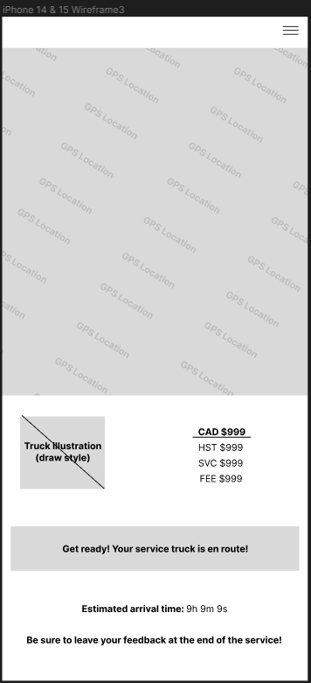**

**Wireframe 4:**

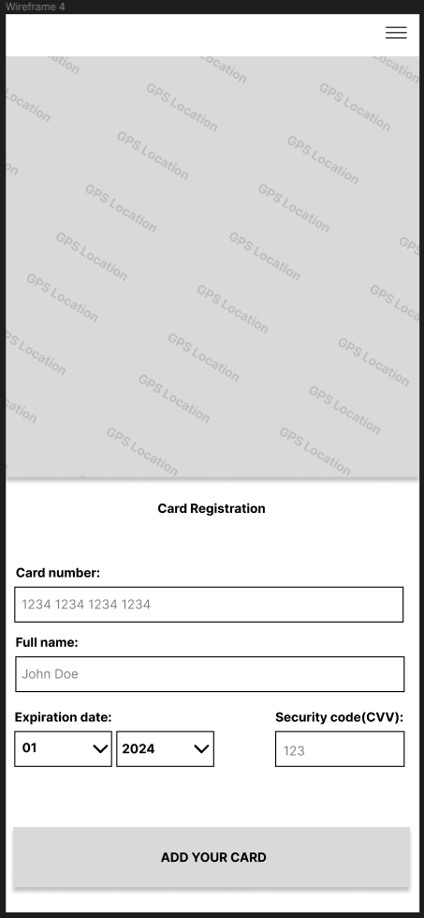

**Error Message 1:  
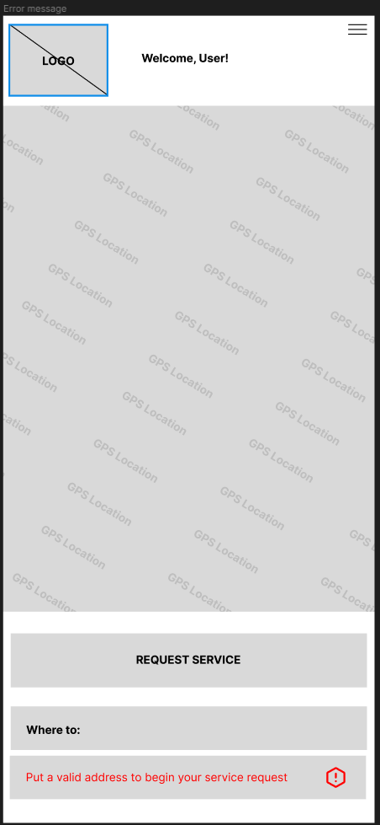**

**Error Message 2:  
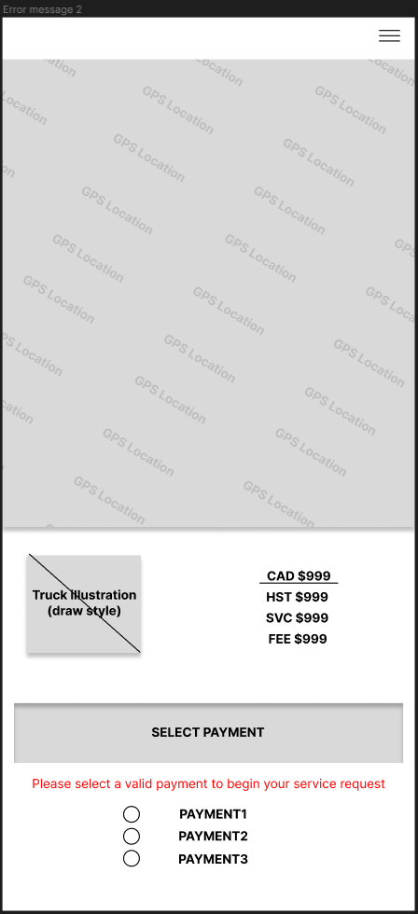**

**Error Message 3:  
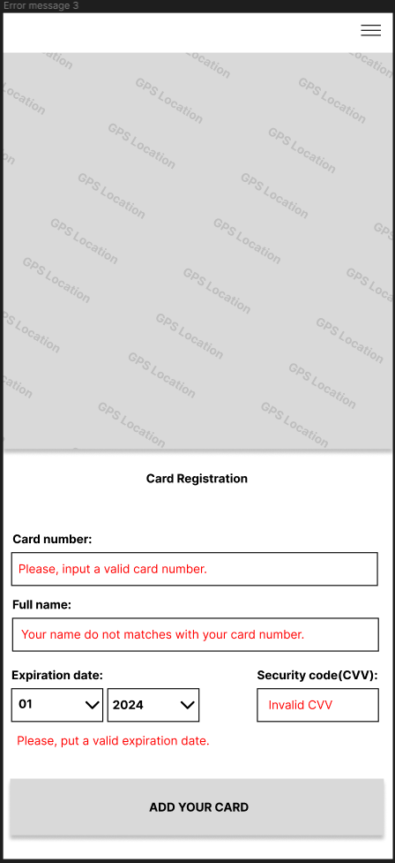**

**Error Message 4:**

